**Acknowledgement**

First of all, we thank The Almighty God for blessing us and supporting us throughout this endeavour. We take this opportunity to express our profound and sincere gratitude to our principal **Dr.D A Kulkarni** for his constant encouragement throughout the course of this project.We gratefully acknowledge the support extended by Head Of the Department, **Dr.V.S. Rajpurohit** and also thank him for letting us use the lab facilities.

We also take the opportunity to express our gratitude to our course guide **Dr. Sharada.Kori** for her deep exemplary guidance, monitoring and constant encouragement. We are also obliged to the staff members of the department for their cooperation during the period of the project.

Lastly, we thank all our friends without whom this project would not be possible.

**Abstract**

A seven-segment display, or seven-segment indicator, is a form of electronic display device for displaying decimal alphabets-numerals that is an alternative to the more complex dot-matrix displays. Normally seven segment display letter from a-g then numbers from 0-9 quite unlike nine-segment, fourteen-segment and sixteen-segment. Due to these limitations, most display projects go for dot matrix display even with the advantages of sharp display and availability of seven segments. This paper presents various ways of combining two seven segment display to achieve other letters from h-z using piece-wise continuous algorithm via an assembly coded microcontroller

**TABLE OF CONTENTS**

|  |  |  |
| --- | --- | --- |
| **Sno.** | **Contents** | **Pgno.** |
| **1** | **Title** | **1** |
| **2** | **Problem Definition** | **1** |
| **3** | **Components used** | **1** |
| **4** | **Design/functional block diagram** | **1** |
| **5** | **Working model of the final solution** | **2** |
| **6** | **Workingccode for mini project** | **3** |
| **7** | **Conclusion** | **4** |

**1.Title**

Interface seven segment display with Arduino uno to generate 2- digit up counter

**2.Problem Definition**

Interface seven segment display with Arduino uno to generate 2- digit up counter

**3. Components used**

Arduino Uno – 1

Programmer Cable – 1

Seven-Segment Display - 2

Male-Male Jumper Wires

**4. Design/Functional Block Diagram**

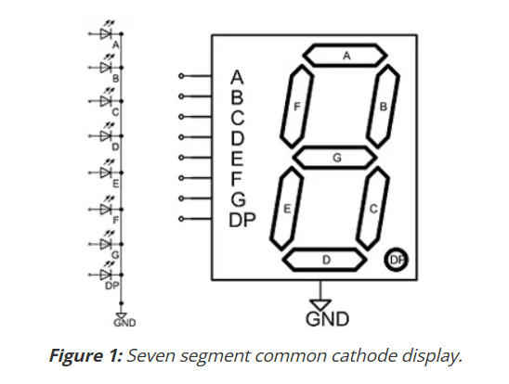

Fig 1.  Seven segment common cathode display.

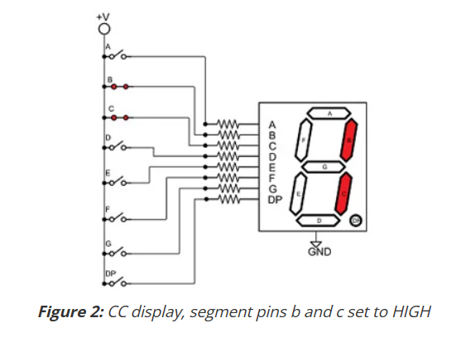

**Fig 2.** CC display, segment pins b and c set to HIGH

**5. Working Model of the final solution**

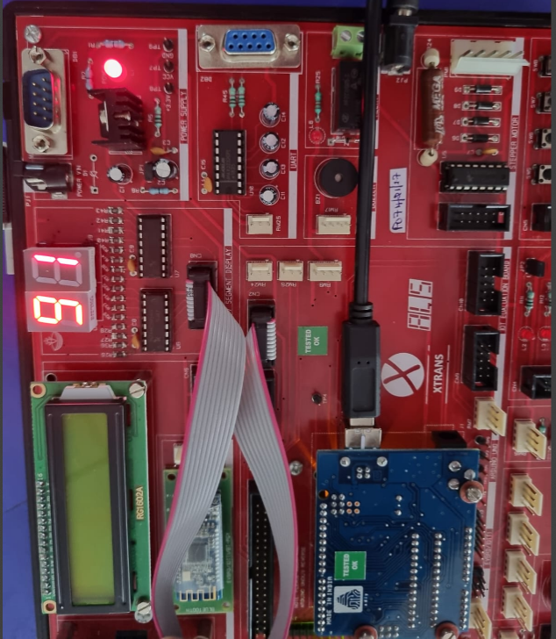

**Fig 2.**Arduino with seven segment display output

**6. Working code for mini project**

#include <ShiftRegister74HC595.h>

// CREATE SHIFT REGISTER OBJECT (NUMBER OF SHIFT REGISTERS, DATA PIN, CLOCK PIN, LATCH PIN)

// CONNECT CN2 to CN8

//ShiftRegister74HC595 sr (2, 12,10,11);

ShiftRegister74HC595 sr (2, 4,2,3);

uint8_t numberB[] = {B00111111, //0

B00000110, //1

B01011011, //2

B01001111, //3

B01100110, //4

B01101101, //5

B01111101, //6

B00000111, //7

B01111111, //8

B01101111 //9

};

void setup()

{

}

void loop()

{

for(int i=0;i<10;i++)

{

for (int j = 0; j < 10; j++)

{

uint8_t pinValues[] = {numberB[i],numberB[j]};

sr.setAll(pinValues);

delay(2000);

}

}

}

**7.Conclusion**

**8.References**

[1] Muhammad Ali Mazidi, Jainice Gillispie Mazidi and Rolin D. McKinlay; The 8051 Microcontrollers and Embedded Systems using Assembly and C, Second Edition, Eastern Economy Edition-2006, Prentice Hall of India Private Limited, New Delhi-110001.

[2]ALS-SDA-8051-MEL User’s Manual, Advanced Electronics, Banagalore-560058, Karnataka, India.